Examplify with ExamID and ExamMonitor
Sep 2, 2020•Tutorial
How-To

You may be assigned to take an exam that uses ExamID and ExamMonitor for remote proctoring.
- ExamID is the software that will validate your identify as an authorized exam taker.
- ExamMonitor is the software that will proctor your assessments.
This guide will help you to set up your device and take your baseline photo.
Note: This information also is available as a video.

Before You Begin
- Select a well lighted, quiet, and distraction-free space in which to take your exam.
- If you are using an external camera or microphone, connect it to the device that you'll use to take the exam.
- Ensure that your device meets the Minimum System Requirements, including the special requirements for ExamID and ExamMonitor. See: Minimum System Requirements
- Download Examplify. See: Examplify for Windows and Mac: Download, Install, and Register Examplify
- Download your exam. See: Examplify: Downloading an Exam

Procedures

- Open Examplify, and select the exam in the Downloads area.
- In the main area of the screen, verify that the exam information includes the ExamID and ExamMonitor tiles.
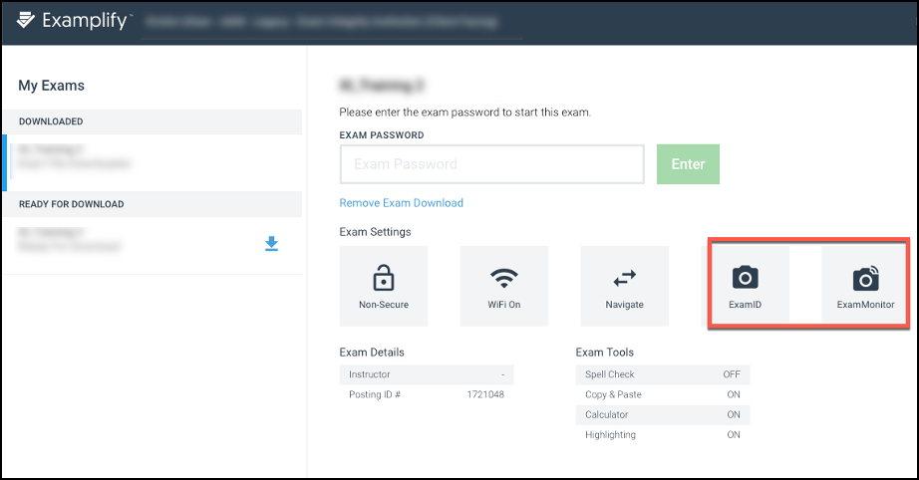
If you do not see the ExamID and/or ExamMonitor tile, verify that you've selected the right exam. If needed, check with your instructor to confirm that this exam will use ExamID and ExamMonitor. If that is the case, and the tiles do not appear, troubleshooting is needed. See: Examplify: ExamID and ExamMonitor Troubleshooting Guide
- Enter the exam password.
- Accept the agreements and permissions.
- After you enter your exam password to begin your exam, you’ll be guided through a series of prompts.
  - Welcome: After reading the message, select Get Started.
  - Consent: You'll see a consent agreement about collecting your biometric data. Select the checkbox and then select Next.
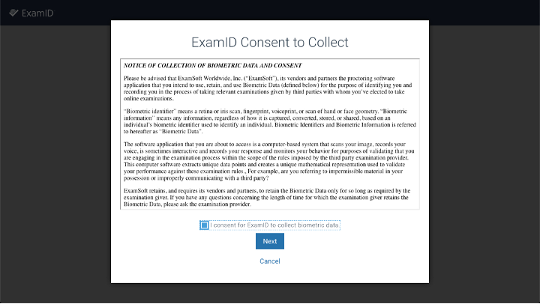
  - Permissions: You'll be prompted to allow Examplify to use system resources, including your camera and microphone. Acknowledge all of these messages and allow these permissions.
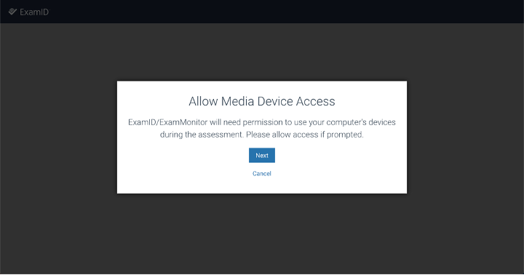
If you need more information about these settings, see:
    - Mac Permissions
    - Windows Permissions
- After you've granted permissions, select the camera and the microphone that Examplify will use to monitor your actions during this exam.
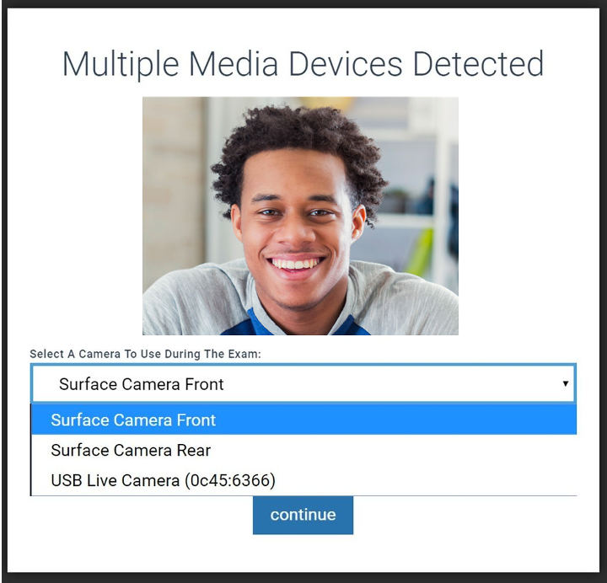
Important: After you select a microphone, confirm that green bars appear. They indicate a functioning microphone. If green bars do not appear, review your system settings, or select a different microphone.
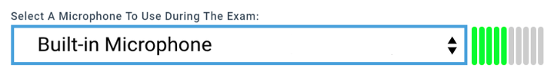
- To prepare to take your baseline photo, make sure that your webcam is uncovered and is aligned for a straight-ahead view of you as you use your device. Position yourself so that you are facing the camera, and remain still.
- Select Continue, and Examplify will attempt to take your photo.
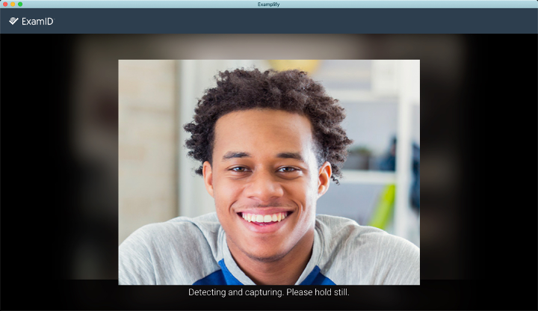

  - A successful auto-detection will place a circle around your face, and you can then select Save & Continue.
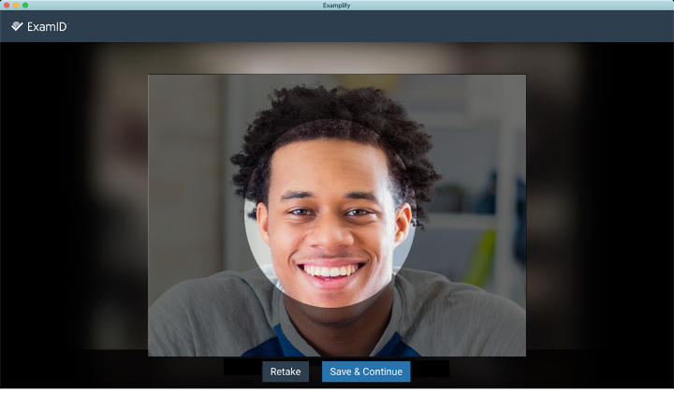
  - If the image looks blurry, reposition yourself as needed, remain still, and then select Retake to take another photo.
- Take the exam. As you take the exam, you might notice two indicators of the monitoring:
  - Your camera light is on.
  - At the top of the screen is a pull-down menu that is labeled Monitoring. You can ignore this menu and focus on taking your exam. (If you select the menu, you'll see your live video feed. To close it, select any other area of the Examplify screen.)
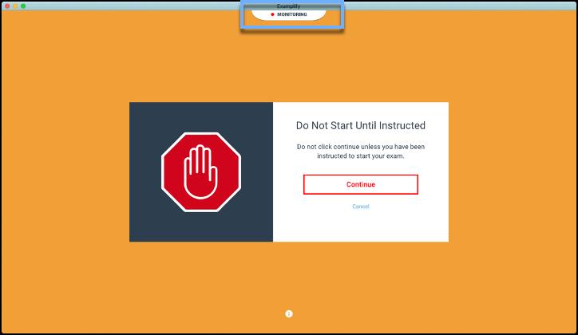
- When you're ready to submit your exam, select Finish, or select Home Menu > Submit Exam.
Important: Follow the on-screen instructions, and keep Examplify open until your exam and the monitoring files are successfully uploaded. If you wi sh, you can minimize Examplify, but do not close or quit Examplify. Do not disconnect from your network. Depending on the exam length and the network speed, the upload process could take some time. Uploading a 90-minute exam with a 2 MB upload connection takes about 10 minutes. With a shorter exam or a faster upload speed, the upload process might take only 2-3 minutes.
- Check the dashboard periodically to determine the file status.
On the left side of the screen, under My Exams, Examplify will indicate that the exam is uploading or that the upload is completed. When the exam appears in the Completed section with a green checkmark, then you can close Examplify and shut off your computer or disconnect from the network.
